[West] African Renaissance
in collaboration with Christie’s Dubai
14 November - 14 December, 2021. Christies Dubai, U.A.E.

Accra’s premier art gallery announces its upcoming group exhibition [West] African Renaissance in
Dubai featuring works by some of its most significant artists from West Africa.

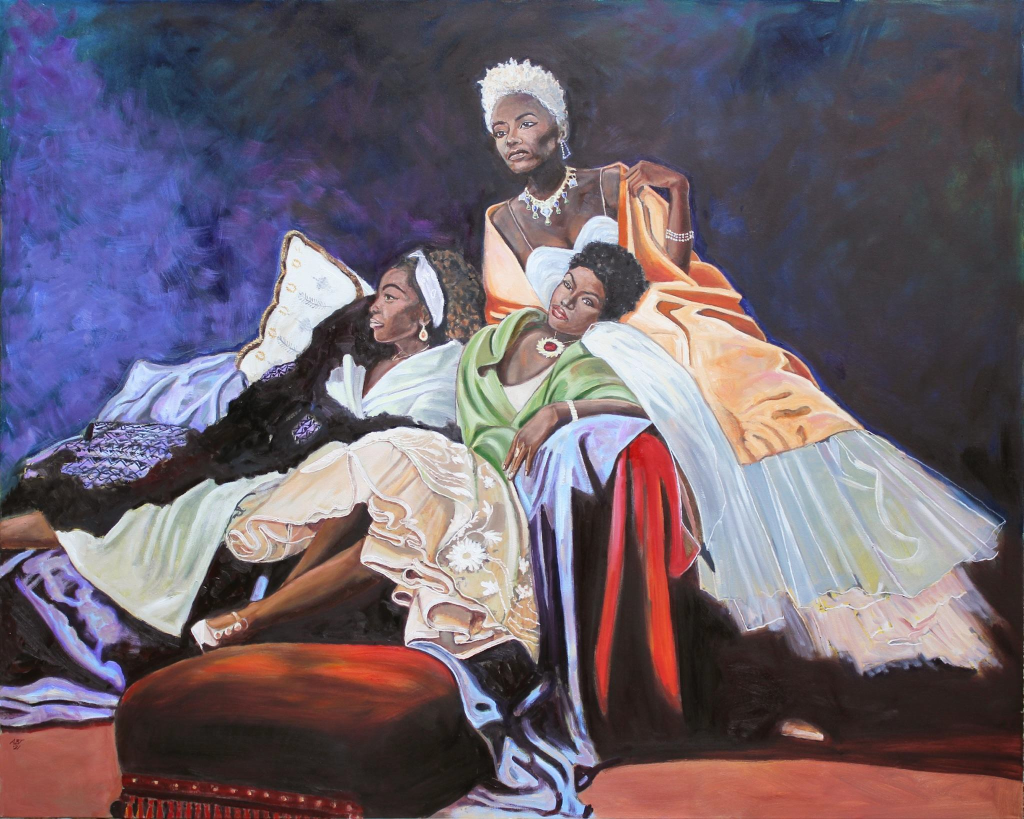

ARTHUR TIMOTHY The Repose, 2021. Oil on canvas. 121.9 x 152.4 cm 48 x 60 inches
Copyright the Artist. Photo courtesy Gallery 1957.

On November 14 and for the duration of one month, Gallery 1957 will open [West] African Renaissance, an exhibition in collaboration with Christie’s Dubai. On view will be a selection of its most esteemed artists from West Africa, such as Ghanaian artists Gideon Appah, Kwesi Botchway, Joshua Oheneba Takyi, Lord Ohene Okyere Bour, Annan Affotey, Serge Attukwei Clottey, Isshaq Ismail Godfried Donkor, Arthur Timothy and Afia Prempeh as well as works by Nigerian painters Oliver Okolo, Juwon Aderemi, and Peter Ojingiri. These artists have been trailblazers in what is

considered to be a Renaissance for modern and contemporary art from Africa and the African diaspora, with artists from the continent gaining recognition regionally and globally.

Over the last decade, artists from the African continent have been displayed at art fairs, biennials, major exhibitions and are included in the permanent collections of some of the world’s most established art institutions. Art fairs dedicated solely to artists from Africa and the diaspora now take place throughout the world, further defining the importance of modern and contemporary art from Africa—a continent that has always been influential.

The paintings included in [West] African Renaissance capture Africa, and more specifically, the nations of West Africa on the brink of ideological change, as seen by artists within the continent. They mark a West African cultural Renaissance that has been rising for many years. Finally, as the poignant figures in these works seem to say, and as the artists would undoubtedly agree, the world is noticing us.

Marwan Zakhem, Founder of Gallery 1957,

“Working with Christie’s, a vocal promoter of African Contemporary art internationally is an obvious fit,” said Marwan Zakhem. “Our focus has always been to support the careers of West African artists, and to ensure they continue to reach new audiences on the global stage. In partnering with Christie’s Dubai, the ever-flourishing creativity of the continent will continue to be seen by international audiences in a part of the world where collectors have long championed our work.”

Michael Jeha, Chairman Christie’s Middle East,

“Following the ongoing collaboration with 1:54 Contemporary African Art Fair, Christie’s is delighted to partner with Gallery 1957 to present a wonderful exhibition of contemporary African art to our longstanding clients and interested audience in the Middle East and beyond. Christies.com will feature the entire exhibition online to engage an even wider arts community, offering a truly international platform to a very talented generation of African artists,” commented Michael Jeha, Chairman Christie’s Middle East.

About the Artists:

Ghanaian artists such as Isshaq Ismail, Kwesi Botchway, Annan Affotey, Lord Ohene and Afia Prempeh, the latter one of Ghana’s up and coming female artists, are known for their startling take on African portraiture, incorporating the social context of their sitters in each work.

Others, like Gideon Appah and Joshua Oheneba Takyi, delve into abstract figuration, often using the human form as an abstract backdrop within a surrealist setting of objects, luscious landscapes, architecture, daily rituals, and African folklore. Oheneba Takyi, for example, is known for his signature use of the chair in each of his paintings—the inanimate object obscures his human forms

through its own shape and color. Gideon Appah, on the other hand, immediately immerses his spectators into a surrealist playground of jewel-like compositions that are akin to dreams. Nature and ghostly reflections of human figures emerge to reflect on the artist’s familial history as well as that of his country. Godfried Donkor’s meticulous paintings incorporate collage amidst his highly detailed figures to explore the socio-historical relationships of Africa and Europe.

Also presented in the exhibition are several of Attukwei Clottey’s intimate charcoal drawings that re-appropriate the use of African masks from the colonial Western artistic practices of the 20th century. Clottey is an artist working in a variety of media, from installation to sculpture, and from photography to performance.

Born in Sierra Leone to Ghanaian parents, Arthur Timothy recently celebrated his first solo exhibition at Gallery 1957, marking his debut in the country of his birth. A qualified architect, Timothy’s vivid oil paintings offer vibrant depictions of post-colonial life through recollections of his childhood, which was spent in Ghana, Sierra Leone and the United Kingdom.

Nigerian painters on view include Oliver Okolo, Juwon Aderemi, and Peter Ojingiri. Like their Ghanaian artist neighbors, they similarly focus on the African individual, painting men and woman from everyday life but with a heightened sense of abstraction. These artists often play with their subjects’ gaze.

About Gallery 1957

Based in Accra, with a London outpost opened in 2020, Gallery 1957 has a curatorial focus on West Africa. Presenting a programme of exhibitions, installations and performances by the region’s most significant artists, the gallery serves as a vital platform, promoting West Africa’s presence within the art scene by hosting ambitious exhibitions, providing resources for residencies and participating in international art fairs. Founded by Marwan Zakhem in 2016, Gallery 1957 has evolved from over 15 years of private collecting. The gallery now hosts three spaces in Accra – one in the Kempinski Hotel and two in the Galleria Mall – and a London outpost in Hyde Park Gate.

Group Exhibition: [West] African Renaissance - Gallery 1957 in collaboration with Christie’s Dubai
Dates: 14 Nov - 14 Dec, 2021
Opening: 14 November, 2021
Address: Gate Village, Building 5, Podium Level, Dubai International Financial Centre ,Dubai, UAE Email: esi@gallery1957.com

www.gallery1957.com
@Gallery1957

